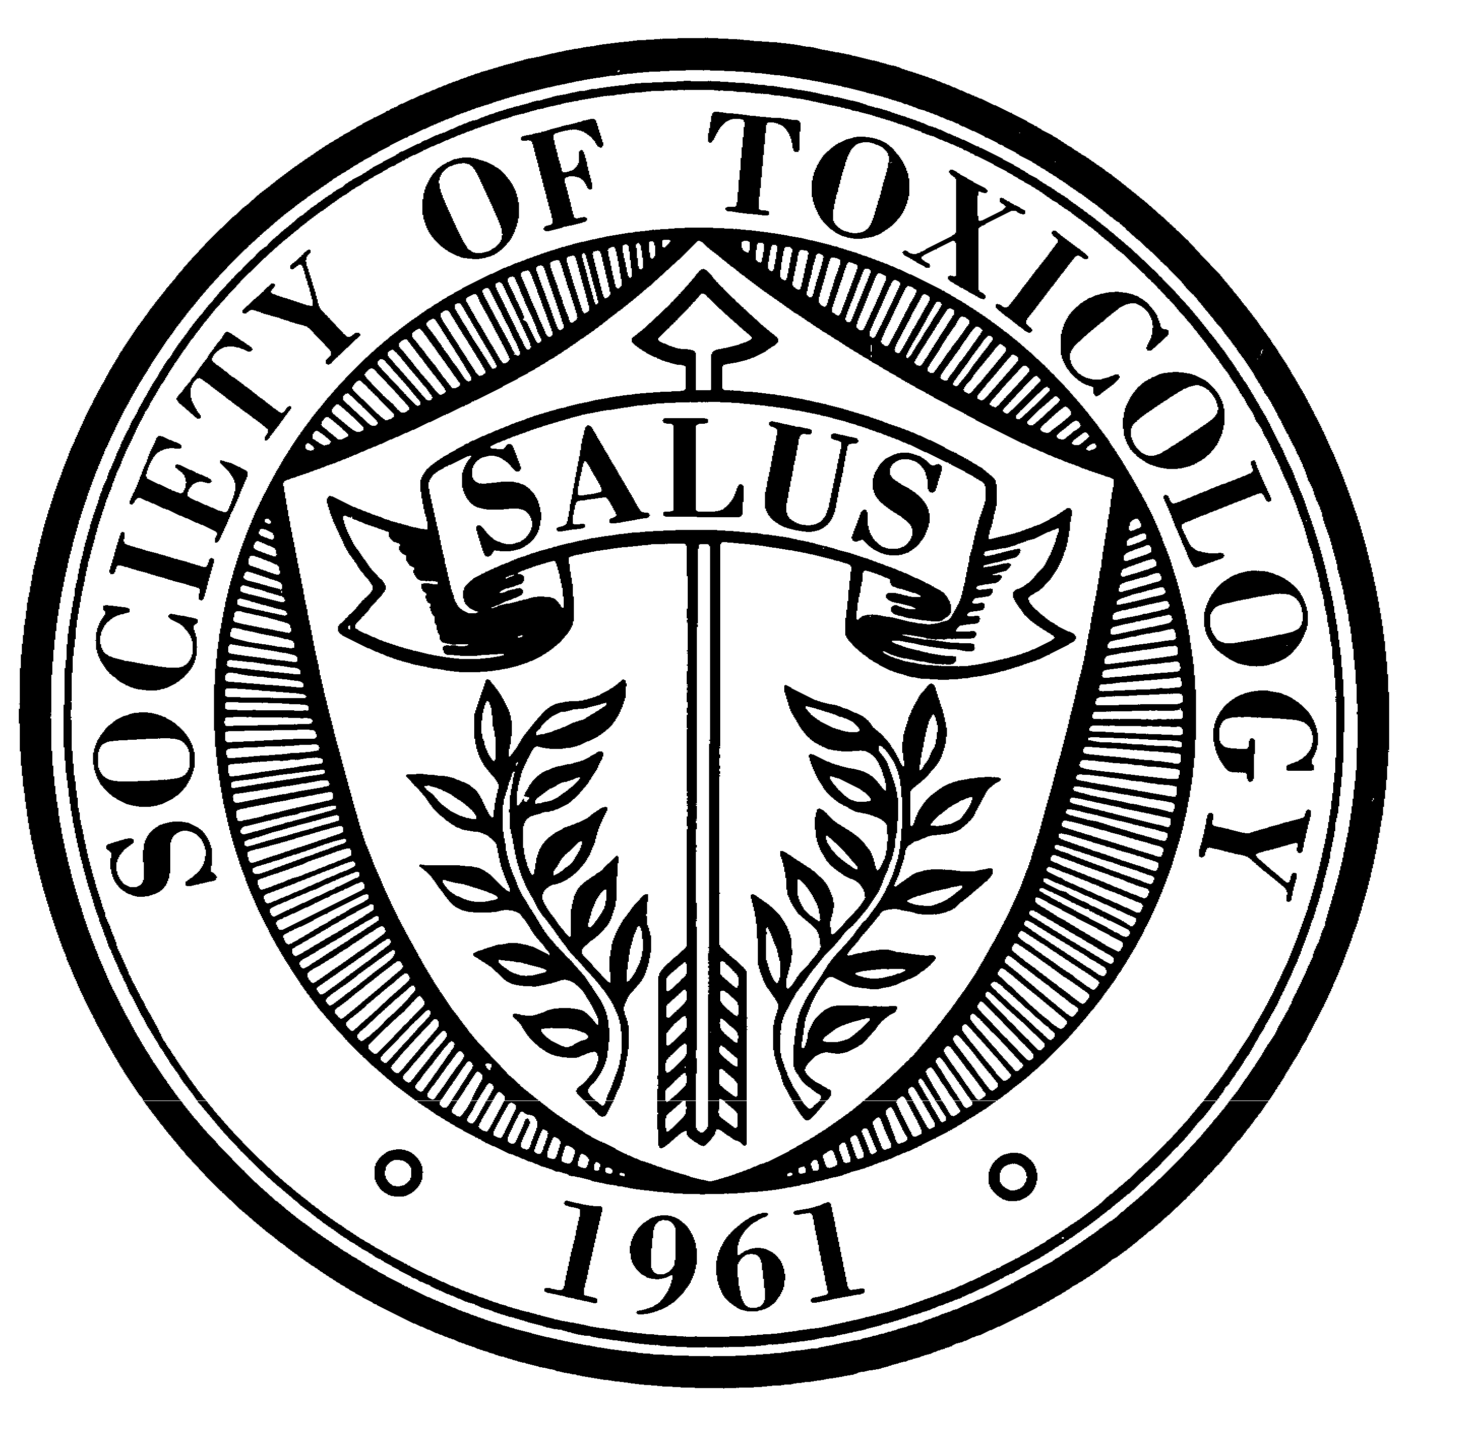  FOR IMMEDIATE RELEASE | Society of Toxicology  1821 Michael Faraday Drive  Suite 300  Reston VA 20190  Phone: 703-438-3115  Fax: 703-438-3113  Media Contact: Fred Whiting  Phone: 703-438-3115, ext. 1650  Email: mediarelations@toxicology.org

Toxicologists to Gather in Seattle for Annual Meeting

RESTON, VA. (February 14, 2008) – Nearly 7,000 toxicologists will gather in Seattle for the 47th Annual Meeting of the Society of Toxicology, from March 16 to 20, 2008, at the Washington State Convention and Trade Center.

The Society of Toxicology’s Annual Meeting and ToxExpo brings together thousands of researchers and regulators from universities, government, and industry. Throughout the week, workshops and poster sessions provide up-to-the-minute research and analysis on subjects connected with disease, human and animal health, occupational safety, and many related issues.

Presenters are respected professionals in a wide range of fields, including human medicine, biotechnology, carcinogenesis, epidemiology, public health, food safety, genetic toxicology, immunotoxicology, infusion toxicology, inhalation, in vitro, and nano particles, in addition to neutrotoxicology, occupational health, pathology, pharmacokinetics, pharmacology, regulatory, risk assessment, reproductive and developmental toxicology and veterinary medicine.

The Society of Toxicology, founded in 1961, is a professional organization of nearly 6,000 scientists working in academic institutions, government, and industry worldwide. SOT is dedicated to creating a safer and healthier world by advancing the science of toxicology. For more information, go to www.toxicology.org.

# # #

EDITORS NOTE: To see the full program or arrange to attend a session, reporters are invited to visit, “Just for the Media” at the Annual Meeting page, http://www.toxicology.org/ai/meet/am2008/press.asp.

FOR IMMEDIATE RELEASE | Society of Toxicology  1821 Michael Faraday Drive  Suite 300  Reston VA 20190  Phone: 703-438-3115  Fax: 703-438-3113  Media Contact: Fred Whiting  Phone: 703-438-3115, ext. 1640  Email: mediarelations@toxicology.org

HUMAN HEALTH AND THE ENVIRONMENT ARE THE FOCUS OF SEATTLE CONFERENCE

Reston, VA (Feb. 22, 2008)—Early female puberty. Increasing rates of childhood asthma. Cough medicines for children. Pharmaceuticals in the environment.
These and other issues within the field of toxicology are highlighted at the 47th Annual Meeting of the Society of Toxicology, from March 16 to 20, 2008, in Seattle, Wash.

Nearly 7,000 toxicologists—researchers and regulators from universities, government, and industry from the United States and other countries—are expected at the Washington State Convention and Trade Center for the Annual Meeting. Throughout the week, workshops and poster sessions provide up-to-the-minute research and analysis on subjects connected with disease, human and animal health, occupational safety and related issues.

There are several presentations of particular interest to the media and the public:

- Early female puberty—For a number of years, the media have been concerned about the early onset of puberty in girls, and environmentalists have indicated that changes in the environment may affect female hormones related to puberty and breast cancer. Some scientists think that chemicals in the environment, such as endocrine disrupting chemicals or other dietary factors, may mimic estrogen. This results in rapid development of the mammary gland, putting the gland at higher risk for cancer. Is there a connection between the environment, early female puberty and breast cancer? Scientific reports suggest an association among the environment, early female puberty, and breast cancer.

- Childhood asthma—For unexplained reasons, there has been an alarming increase in the rate of asthma among children. One reason may be particulate chemicals in the environment, but a link between the two hasn’t been scientifically established. However, there is a concern about the long-term consequences of widespread exposure to ozone in sensitive populations, particularly in children. The Annual Meeting brings together the most current basic and applied research on the influence of ozone on the development of the lung.

- Cold medicines and children—U.S. parents spend around $500 million annually to purchase 95 million boxes, containing almost four billion doses of over-the-counter (OTC) pediatric cough and cold products, despite the absence of any published evidence that they are effective. A Food and Drug Administration (FDA) review over past decades identified 123 deaths associated with the use of OTC cough and cold products in children less than six years of age, although there may have been other factors. An advisory panel convened by the FDA produced a vigorous discussion of the need for better data on risks and benefits in children of OTC cough and cold medications. What are the latest findings?

- Pharmaceuticals in the environment—Many studies have documented the presence of low-level mixtures of emerging contaminants, including human and veterinary medicines, in surface water. These findings are gaining increasing attention. Scientists and the media are questioning the potential impact of these substances on human health and on the environment. Significant water reuse in certain regions of the United States and the current state of water treatment underscore the importance of valid exposure assessments related to pharmaceuticals in the environment (PIE). The Federal Interagency PIE Working Group has been formed to identify some of the key issues, data gaps, research priorities, and considerations. The SOT Annual Meeting addresses these issues and provides an interactive discussion among attendees and speakers.

The Society of Toxicology is the leading organization dedicated to creating a safer and healthier world by advancing the science of toxicology. Founded in 1961, it is a professional organization of more than 6,300 scientists who work in academic institutions, government and industry worldwide.

Toxicology is the study of the adverse effects of chemical, physical or biological agents on living organisms and the ecosystem and the prevention and amelioration of such adverse effects. For more information, visit www.toxicology.org.

# # #

EDITORS NOTE: To see the full program or arrange to attend a session, reporters are invited to visit “Just for the Media” at the Annual Meeting page, www.toxicology.org/ai/meet/am2008/press.asp.

